Design database for Zen class programme

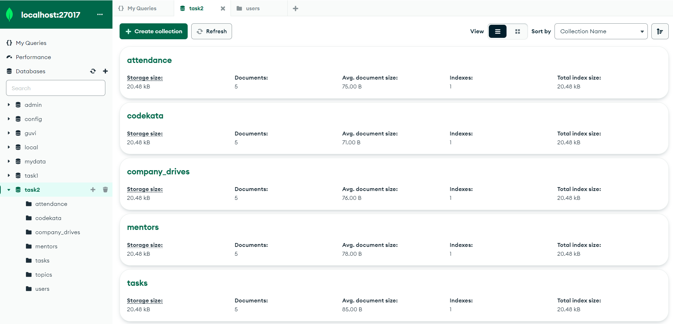

1. Find all the topics and tasks thought in the month of October:

db.topics.find({}).toArray()

db.tasks.find({ submitted_date: { $gte: ISODate("2020-10-01"), $lte: ISODate("2020-10-31") } }).toArray()

2. Find all the company drives that occurred between 15 Oct 2020 and 31 Oct 2020:

db.company_drives.find({ drive_date: { $gte: ISODate("2020-10-15"), $lte: ISODate("2020-10-31") } }).toArray()

3. Find all the company drives and students who appeared for the placement:

db.company_drives.aggregate([

{$lookup: {

from: "users",

localField: "_id",

foreignField: "driveid",

as: "participants" }}]).toArray()

4. Find the number of problems solved by a user in codekata:

db.codekata.aggregate([

{

$group: {

_id: "$userid",

total_problems_solved: { $sum: "$problems_solved" }

}

}

]).toArray()

5. Find all mentors with mentee count more than 15:

db.mentors.find({ "mentees_count": { $gt: 15 } }).toArray()

6. Find the number of users who are absent and tasks not submitted between 15 Oct 2020 and 31 Oct 2020:db.attendance.aggregate

([

{

$lookup: {

from: "topics",

localField: "topicid",

foreignField: "topicid",

as: "topics"

}},

{

$lookup: {

from: "tasks",

localField: "topicid",

foreignField: "topicid",

as: "tasks"

}

},

{

$match: {

status: false,

"tasks.submitted": false,

$and: [

{ "topics.topic_name": { $gte: ISODate("2020-10-15") } },

{ "topics.topic_name": { $lte: ISODate("2020-10-31") } },

{ "tasks.submitted_date": { $gte: ISODate("2020-10-15") } },

{ "tasks.submitted_date": { $lte: ISODate("2020-10-31") } }

]

}

},

{$count: "absent"}])